**Experiment No. 3.3**

**Student Name: Rishav Kumar UID: 22MCC20039**

**Branch: MCA - CCD Section/Group: MCD-1/ Grp A**

**Semester: III Date of Performance: 3rd Nov 23**

**Subject Name: Business Analytics Subject Code: 22CAH-703**

1. **Aim/Overview of the practical:**

Implementation of Dashboard in Tableau.

**2. Code for practical:**

Implementing a dashboard in Tableau involves creating a collection of visualizations that are presented together on a single screen for easy data analysis and insights. Here are the steps to implement a dashboard in Tableau:

**Step 1**: Connect to Data Source Open Tableau Desktop and connect to your data source. Ensure that the necessary data is available and properly formatted for dashboard creation.

**Step 2:** Create Visualizations Build the individual visualizations (charts, graphs, maps, etc.) that you want to include in the dashboard. Use the "Show Me" feature in Tableau to quickly choose appropriate visualization types based on your data.

**Step 3:** Organize Visualizations Drag and drop the visualizations onto the dashboard canvas. Arrange them to create a logical flow and intuitive layout. Use containers and layout tools to align the visualizations neatly.

**Step 4:** Add Interactivity Make the dashboard interactive by adding actions and filters. Utilize filter actions, highlight actions, URL actions, etc., to allow users to interact with one visualization and dynamically affect others.

**Step 5:** Format and Customize Format the dashboard to make it visually appealing and user-friendly. Customize colors, fonts, and layout to match your organization's branding or the intended audience. 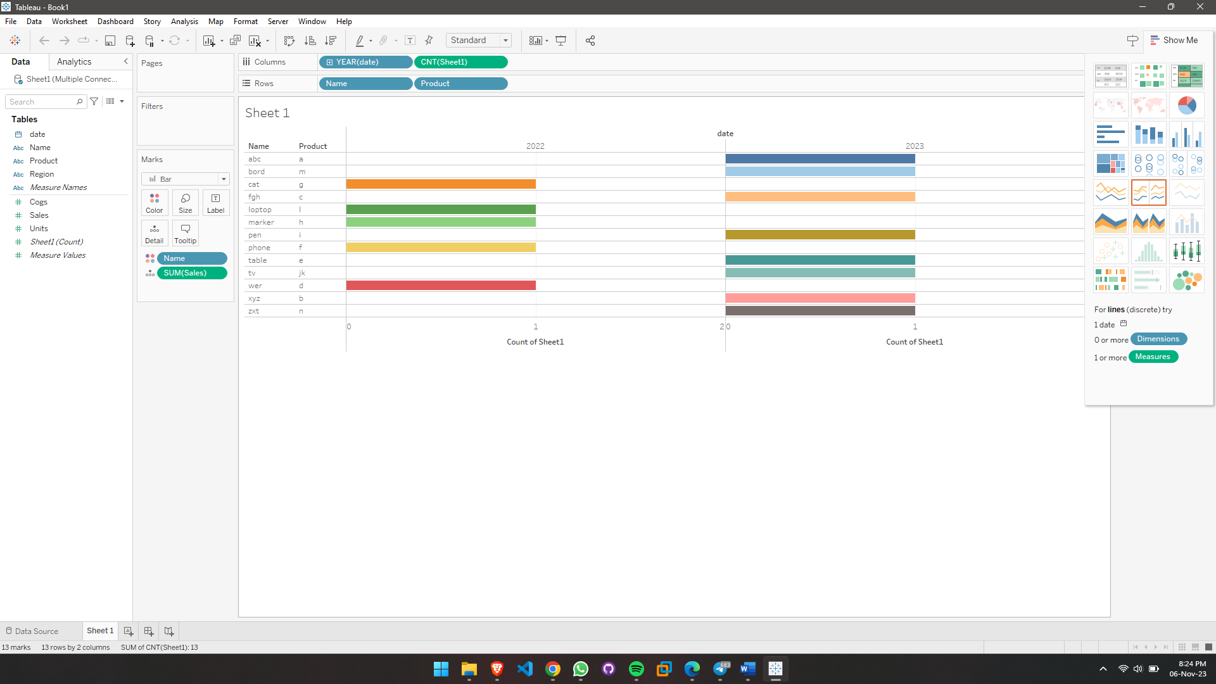

**Step 6:** Add Text and Annotations Include text boxes, titles, and annotations to provide context and insights. Describe the purpose of the dashboard, explain the visualizations, and highlight key findings

**Step 7:** Test and Validate Test the dashboard to ensure it works as expected. Validate the data, interactivity, and navigation. Verify that the visualizations accurately represent the underlying data.

**Step 8:** Review and Refine Review the dashboard for clarity, consistency, and effectiveness. Refine the design and content based on feedback from stakeholders or end-users.

**Step 9:** Publish the Dashboard Publish the dashboard to Tableau Server, Tableau Online, or Tableau Public (if applicable). Choose the appropriate permissions and access controls to share the dashboard securely.

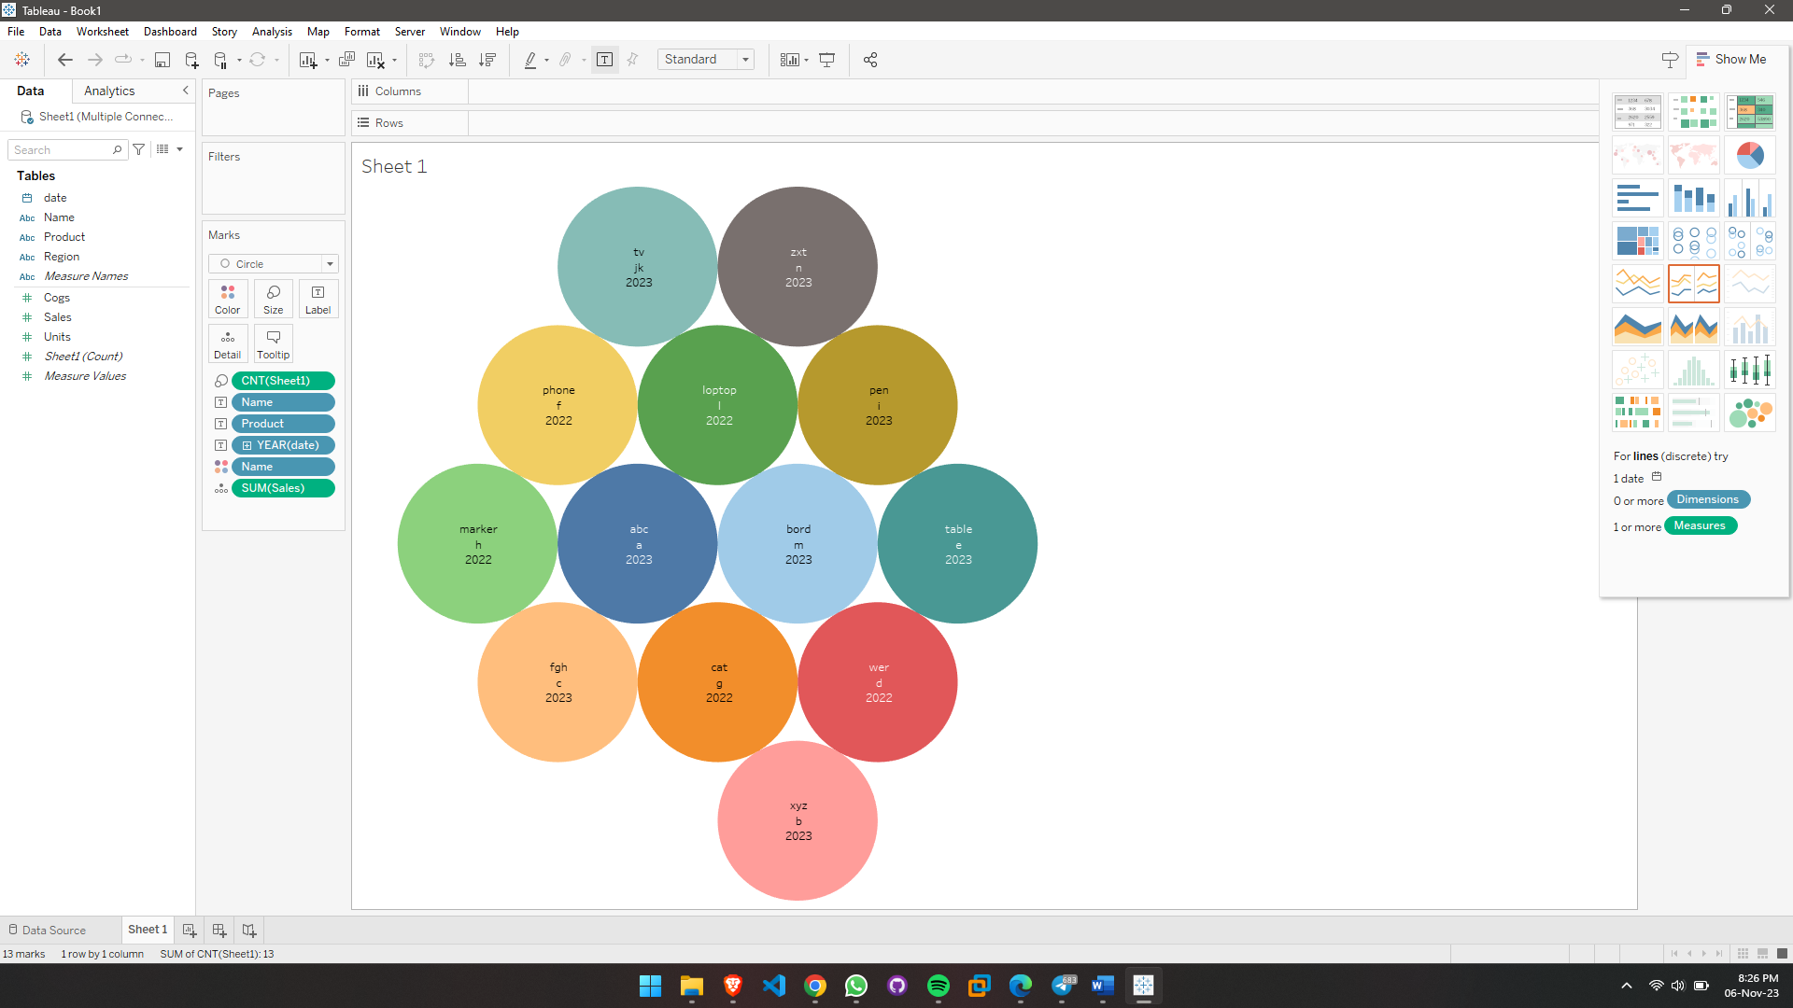

**Step 10:** Share and Collaborate Share the dashboard with relevant stakeholders and encourage collaboration. Train users on how to interact with the dashboard effectively for data analysis and decision-making.

**************************************** **THE END** ***********************************************